API Setup

Folder structure and API folder
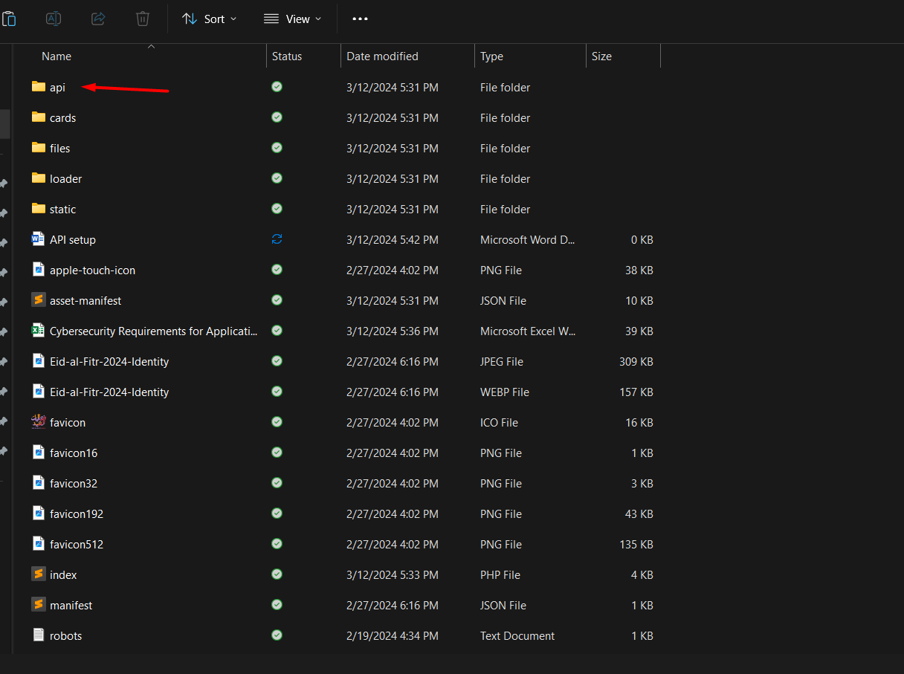
API folder is placed in the project root like other folders as “files”,”loaders” etc.
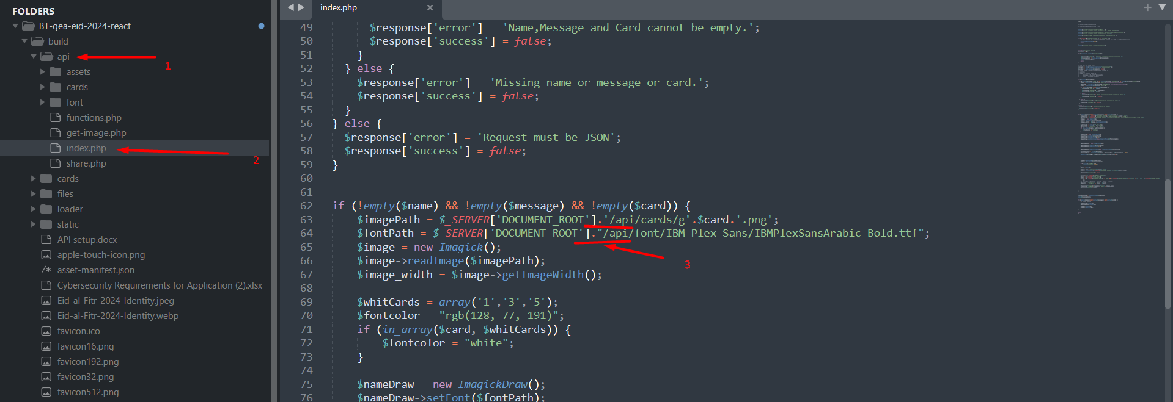

Update the above path. If the build folder is placed in side any subdirectory within the server root then the path needs to be updated within the index.php located inside /api/ folder.
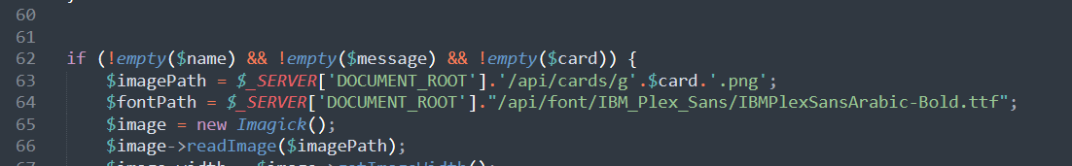

The lines where the path needs to be updated are 63,64,99,108.

Check the following sample:
If the website is hosted in root folder then the path will look like this:

If it is in subfolder then the path is:
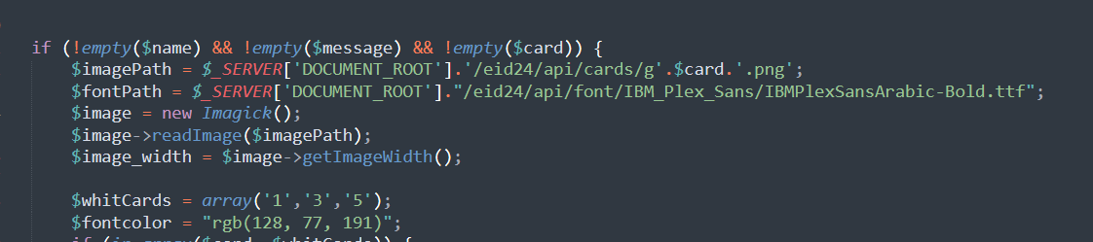
Here the project is placed within a subfolder “/eid24/”.

Once the above changes are done try to test the app by creating a card and if you encounter any error use the debugging mode to identify the issue:
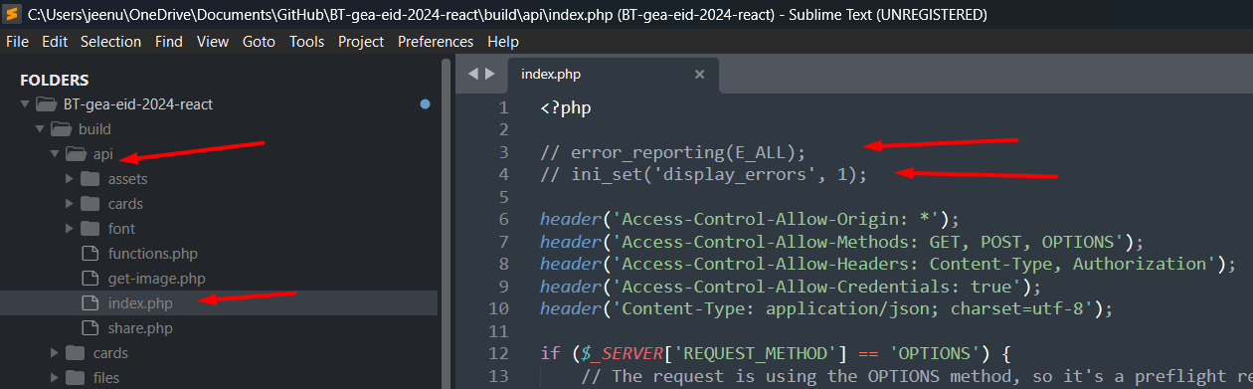
Uncomment the above mentioned lines in index.php and run the application again to check if you encounter any issue. The debugging can be tested in browser’s network tab after clicking “create card”. In case if you encounter imagic extension issue, then you may have to check the current extension and add the latest available. To check the available extension add the below mentioned lines on top of the index.php file within /api/ folder and directly run this file in browser by navigating:
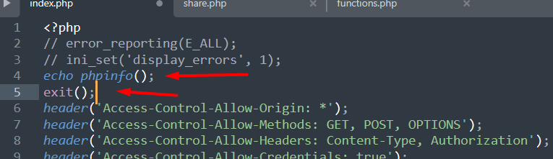
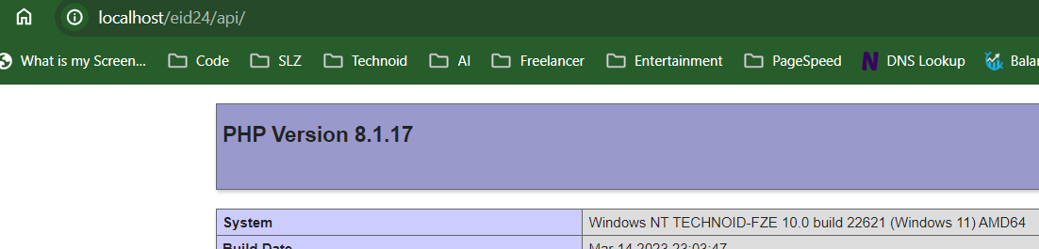
The output will give the php installation detail. Then search for “imagic”
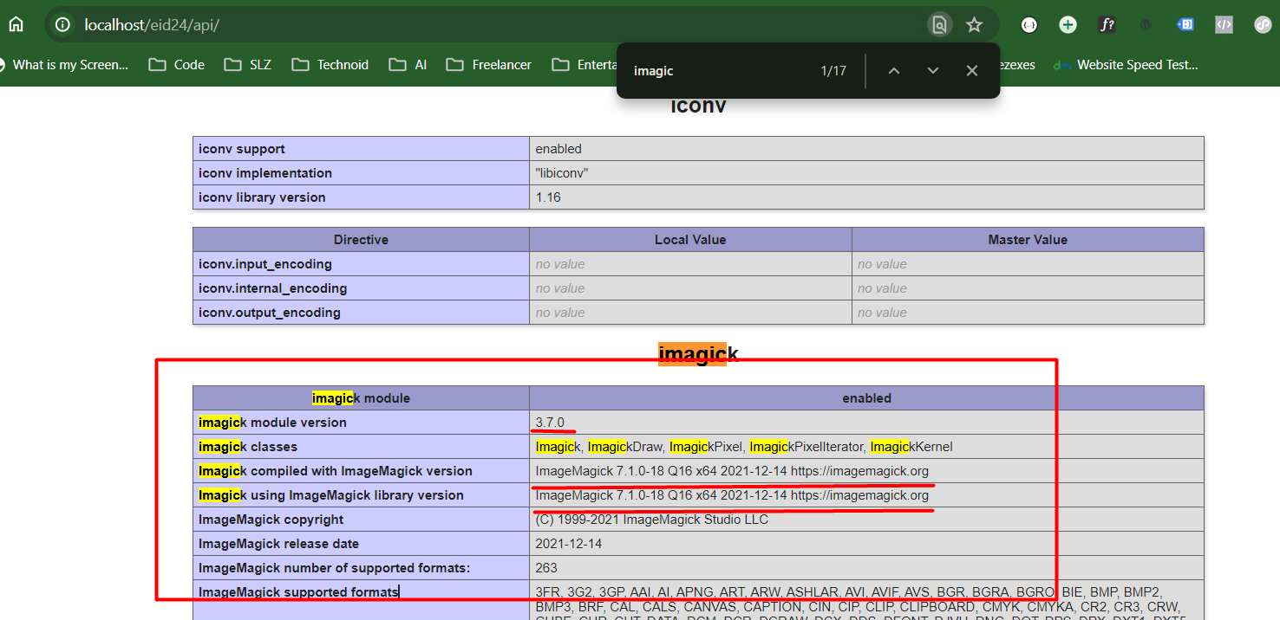
we need to have everything exactly like the one above. If it does not work, then your server has to be fixed to have this package.

